**Manual testing Assessment**

**URL** : https://lapinozpizza.in/

**To Write Separate Testing below Task for Mobile, Web, responsive**

* To cover login process
* To cover pizza selection
* To cover addtocart process
* To cover Cash on Delivery process not to online payment gateway

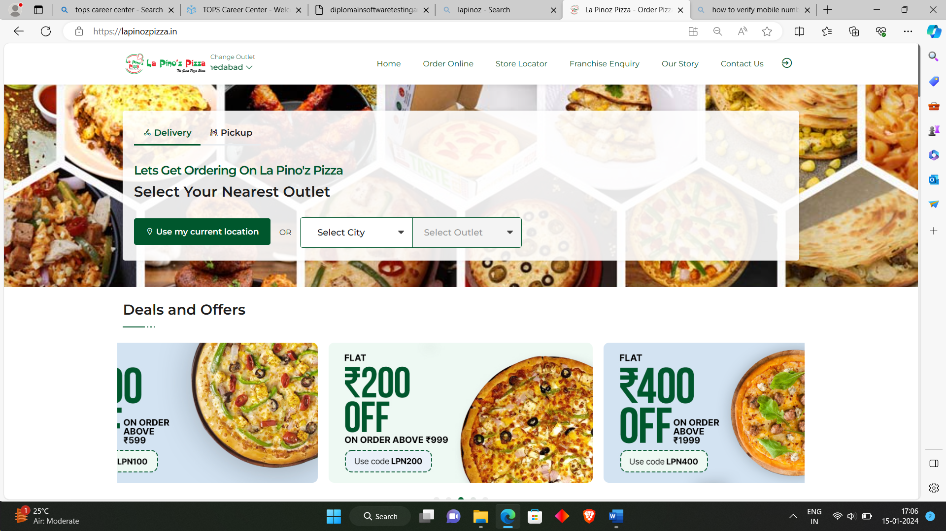

**Task 1)** to create test scenario to order the online pizza process. To check only functional testing in Sheet1

|  |  |
| --- | --- |
| Test Scenario | [Click Here](Assessment_Manual%20testing.xlsx) |

**Task 2)** to create test Case to order the online pizza process of above Test Scenario which you created (Note: with number of test case will create as a positive and negative) (In Sheet2)

|  |  |
| --- | --- |
| Test Cases | [Click Here](Assessment_Manual%20testing.xlsx) |

**Task 3)** to create Responsive Testing and problem write on sheet with screenshot to order the online pizza process (in Sheet 3)

**WEB**

**How to order a pizza online from La Pino’z Pizza webiste via Cash On Delivery process (Web)**

1. Click on URL: <https://lapinozpizza.in/>

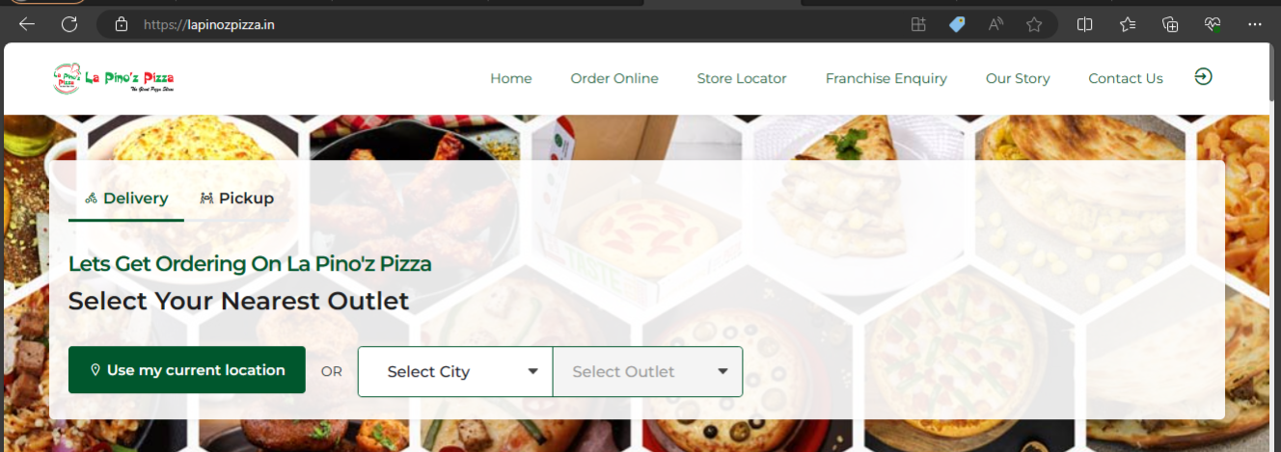

1. Click on ‘Select City’ drop down menu

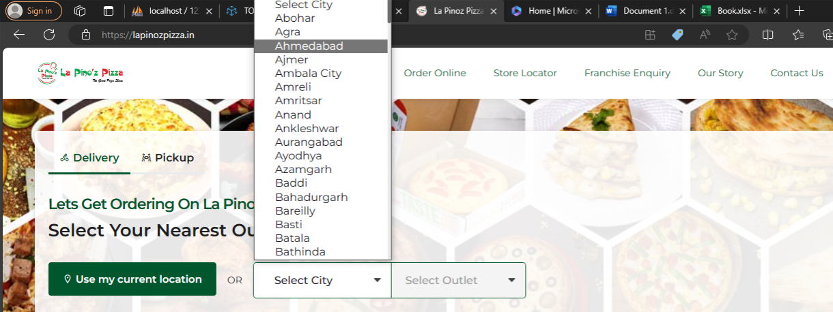

1. Select your nearest outlet from the city selected.

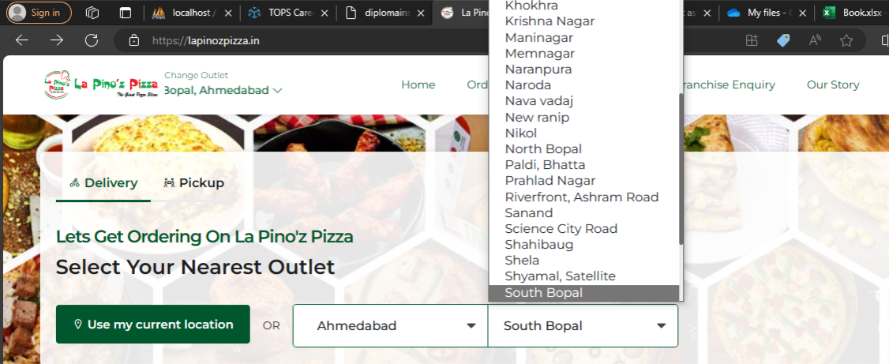

1. Select the type of pizza under ‘Categories’ from left side panel.

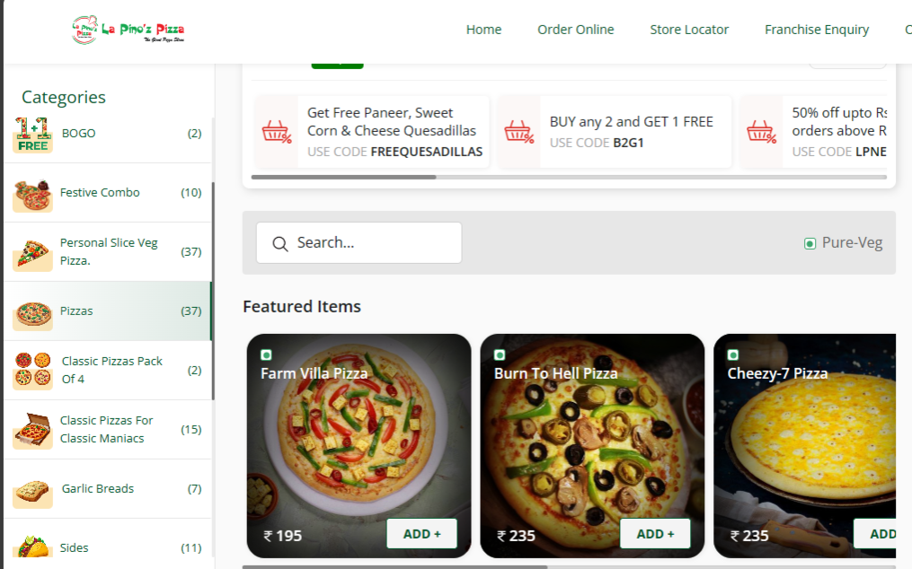

1. Click on ’Pizzas' category. Select Traditional Veg > Pizzas.

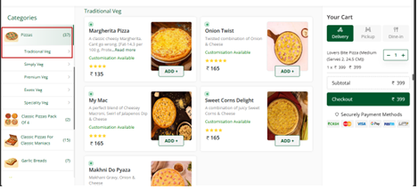

1. Click on any pizza as per choice. Here for eg Margherita Pizza is selected. Click on “Add +” for adding to cart. Click on the size as per choice. For eg Choose “Medium” and click on “Add to Cart”

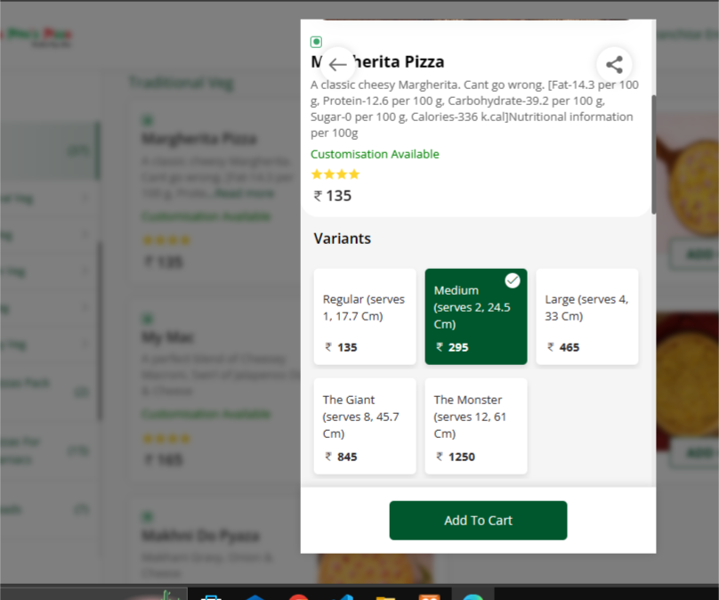

1. Select the number of quantities as per required and click on “Checkout”.

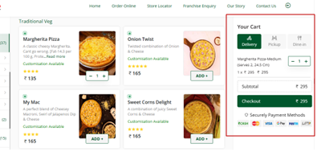

1. Enter your Mobile number for login purpose and click on ‘Send OTP’. An OTP will be sent to user.

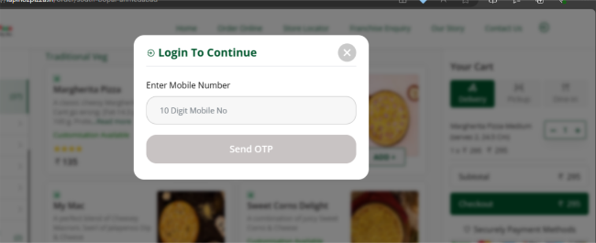 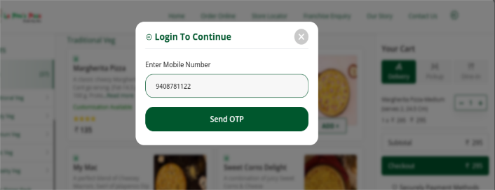

1. Enter the OTP and click on Continue.

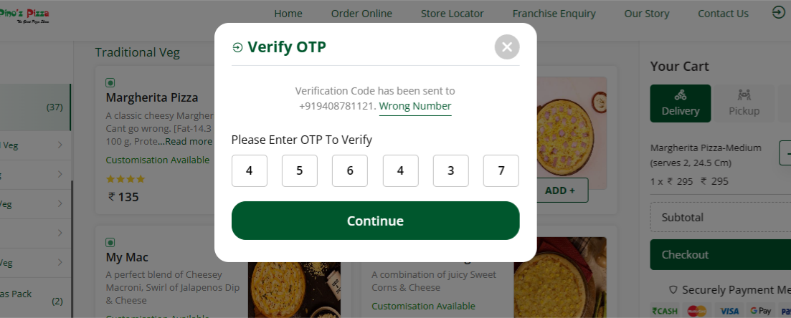

1. After Successful Login , again click on “Checkout”. And click on Select Delivery Address.

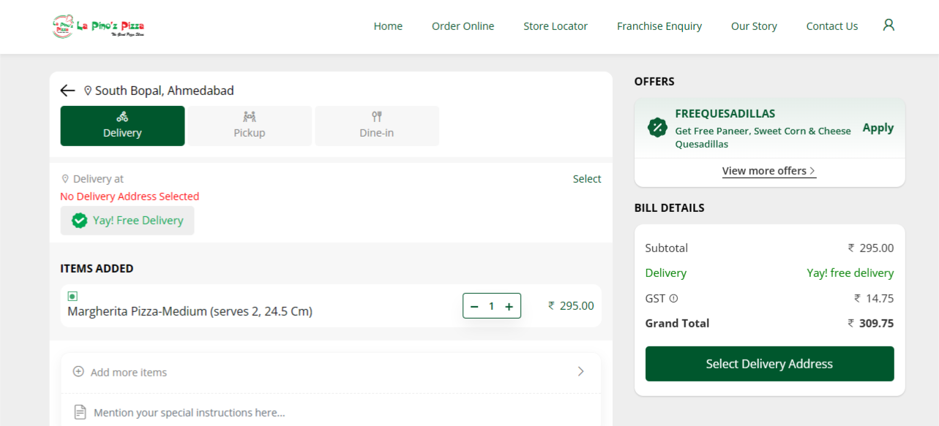

1. Click On “Add New address” and enter the exact location manually or using automatic Geolocation. Then click on ‘Select’ for choosing the the address for delivery.

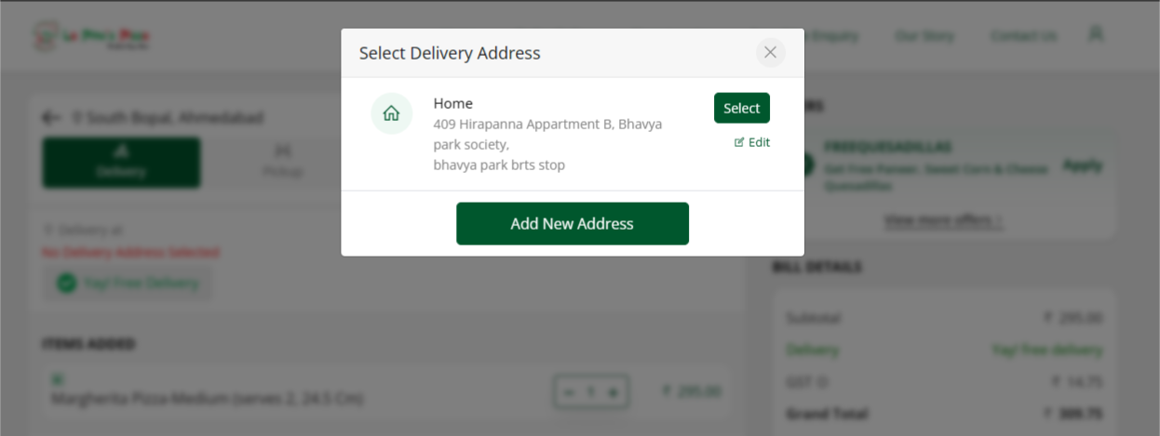

1. Click on “Pay securely”.

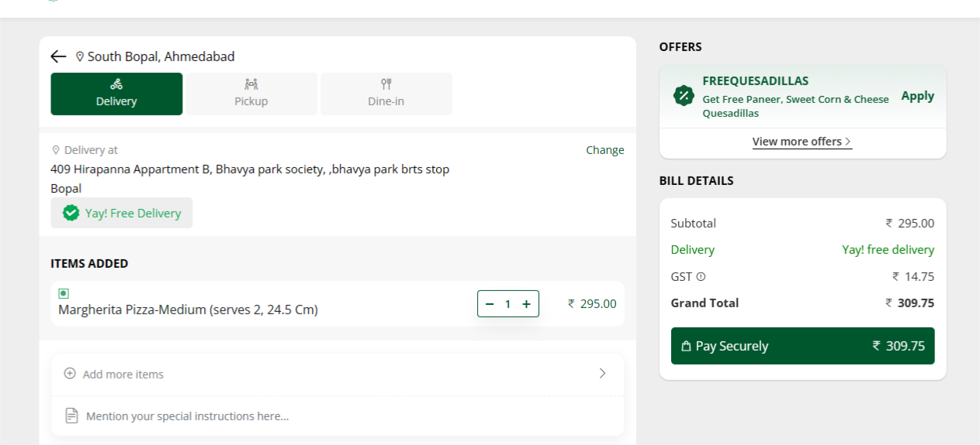

1. Click on ‘Cash’ option in Payment option. But here error message is being displayed saying “Payment By Cash is not available on this order”.

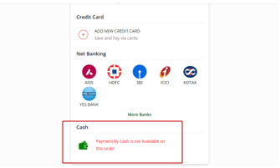

**Issue : Cash on Delivery option is not available for payment option for ordering online via website.**

**Mobile**

**How to order a pizza online from La Pino’z Pizza webiste via Cash On Delivery process**

1. Click on URL: <https://lapinozpizza.in/>

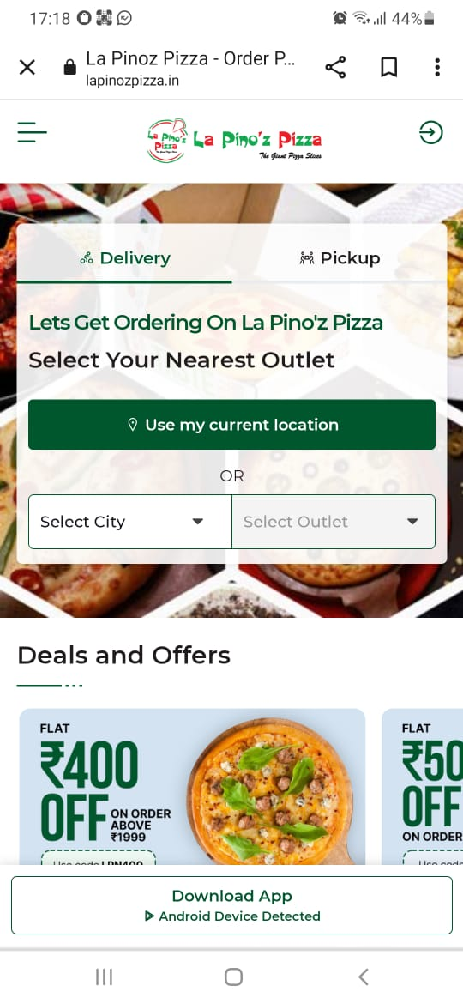

1. Click on ‘Select City’ drop down menu. For eg. Select Ahmedabad city,

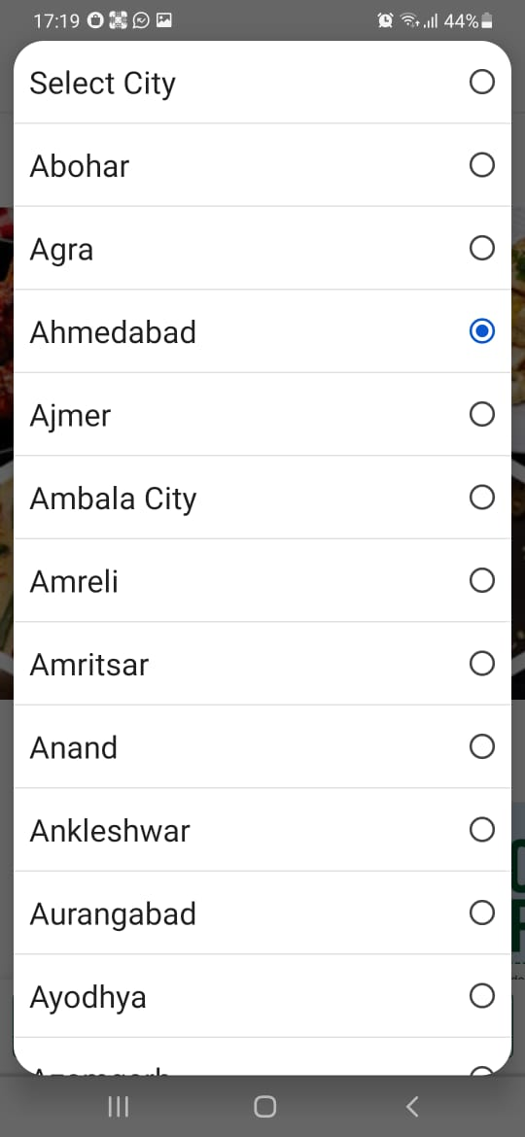

1. Select your nearest outlet from the city selected. For eg Select South bopal outlet.

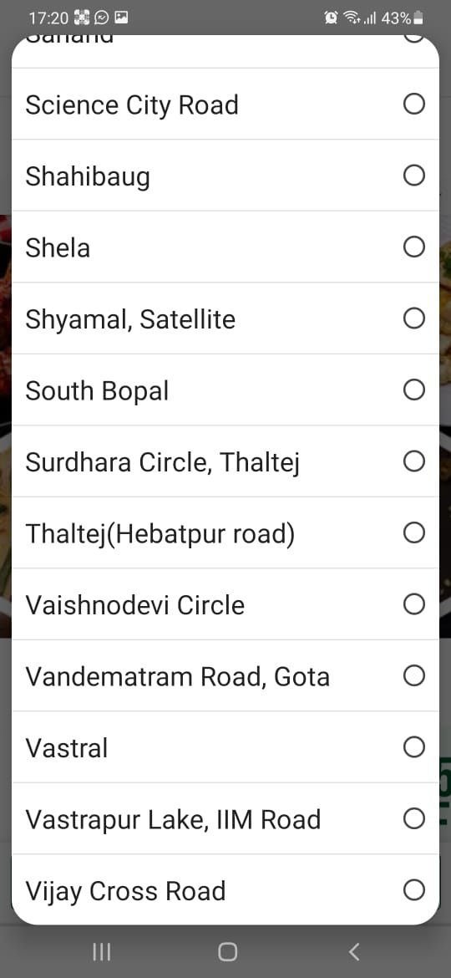 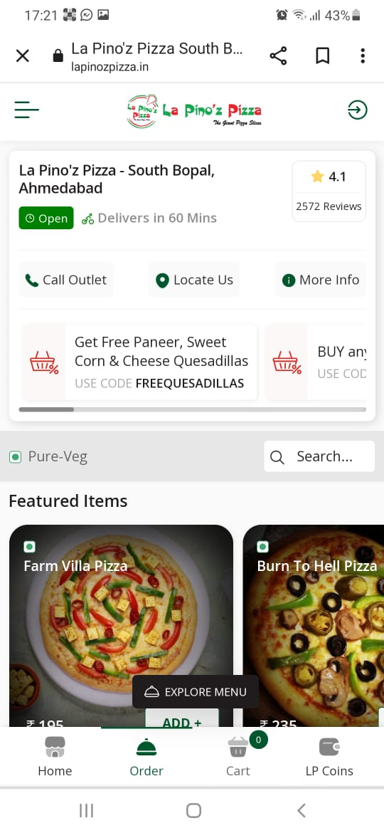

1. Select the type of pizza under ‘Explore Menu’.



1. Click on ’Pizzas' category. Select Traditional Veg > Pizzas.

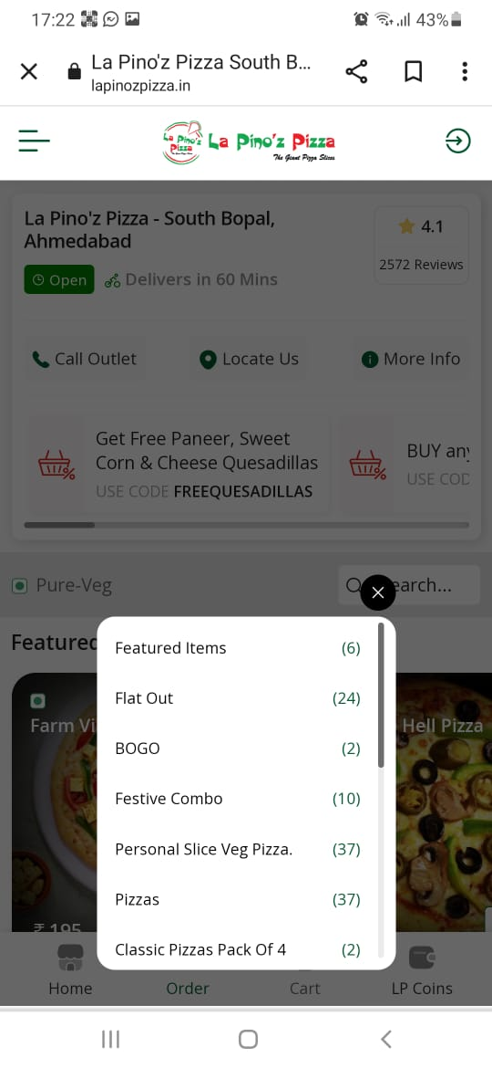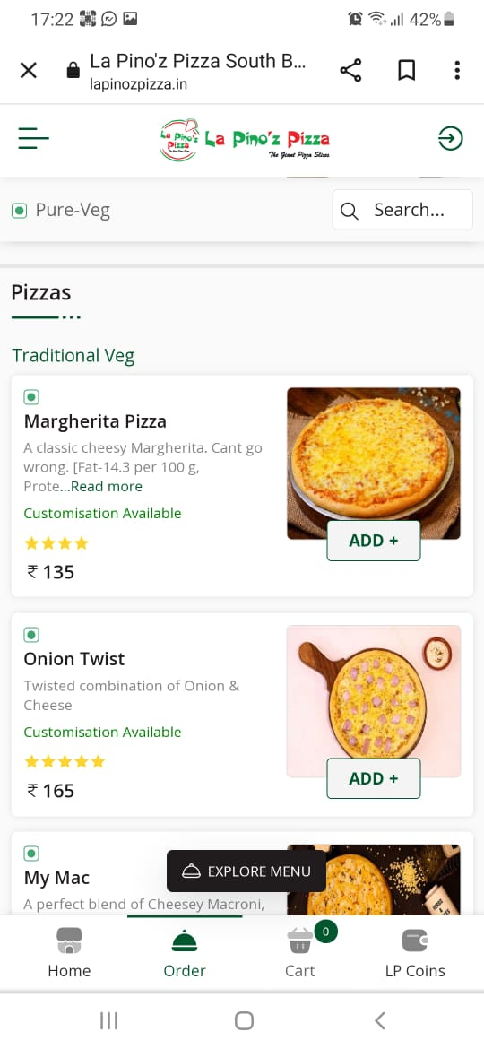

1. Click on any pizza as per choice. Here for eg Margherita Pizza is selected. Click on “Add +” for adding to cart. Click on the size/variant as per choice. For eg Choose “Regular” and click on “Add to Cart”

 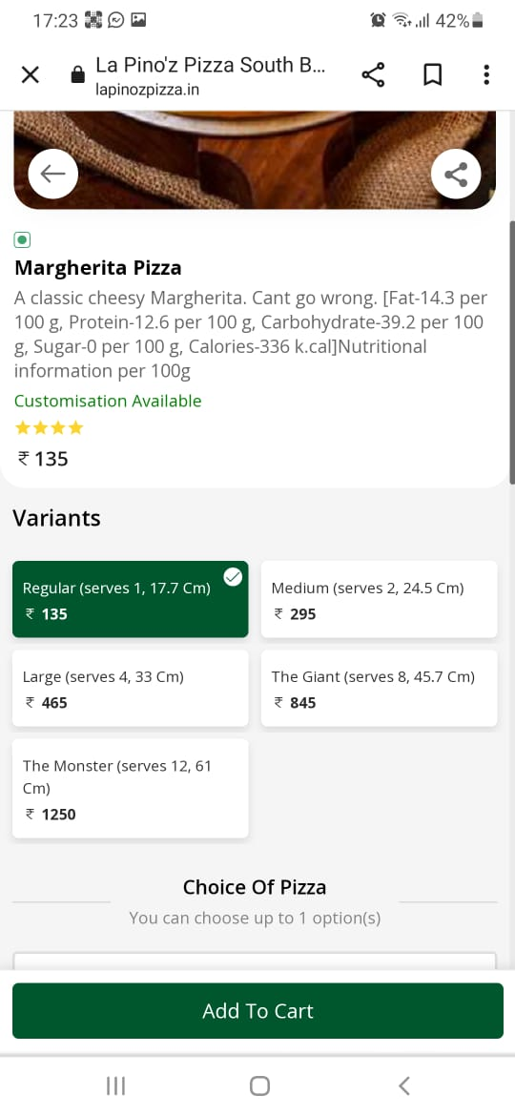 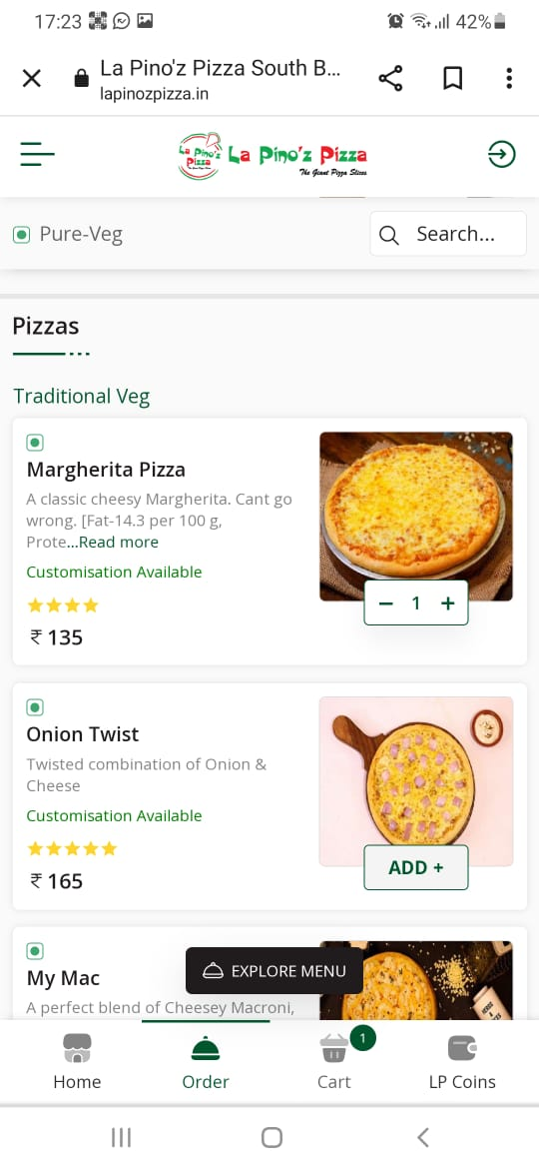

1. Select the number of quantities as per required and click on Cart icon.



1. Enter your Mobile number for login purpose and click on ‘Send OTP’. An OTP will be sent to user.

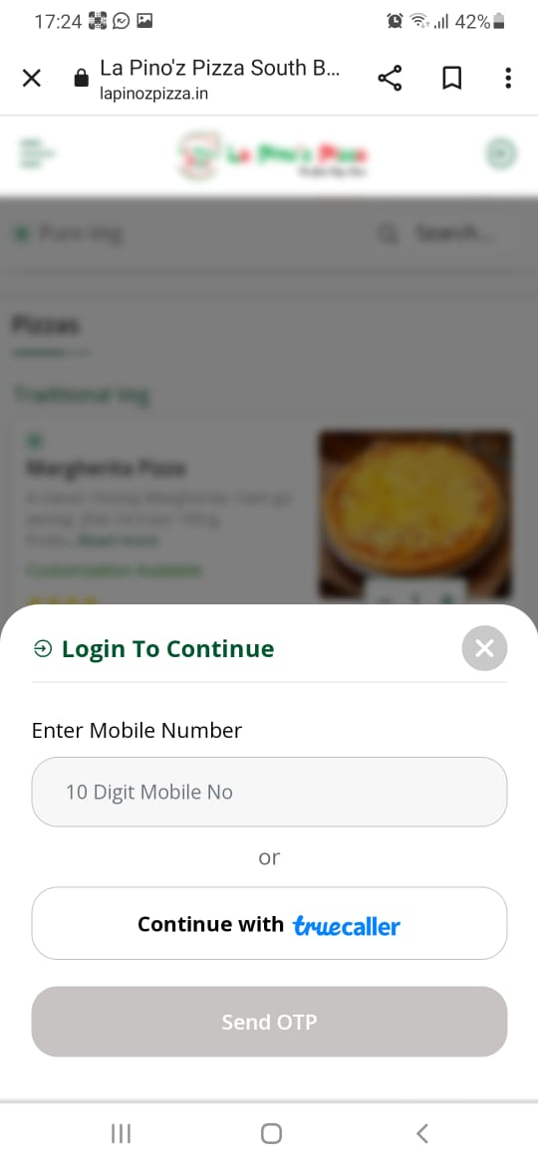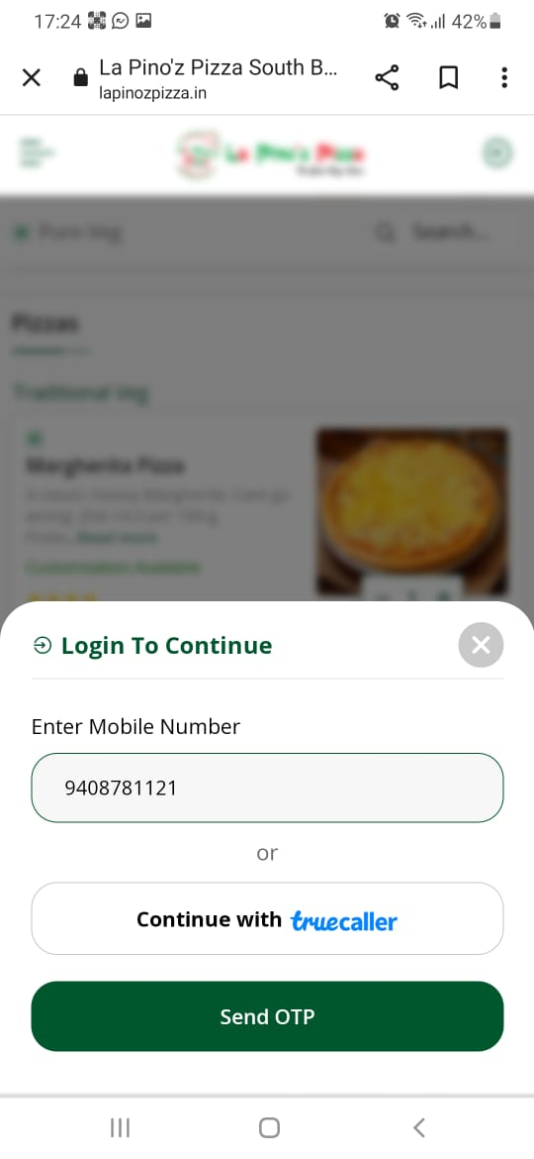

1. Enter the OTP and click on Continue.

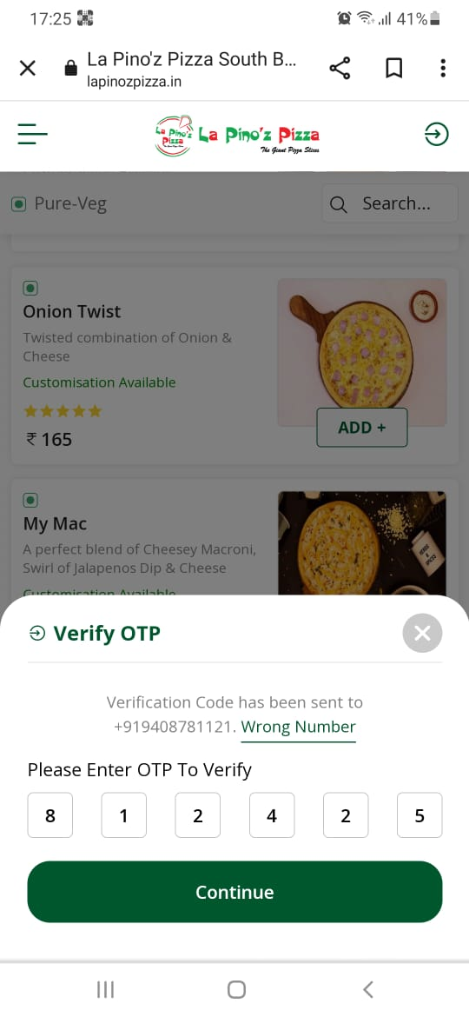

1. After Successful Login , again click on Cart. And click on Select Delivery Address.

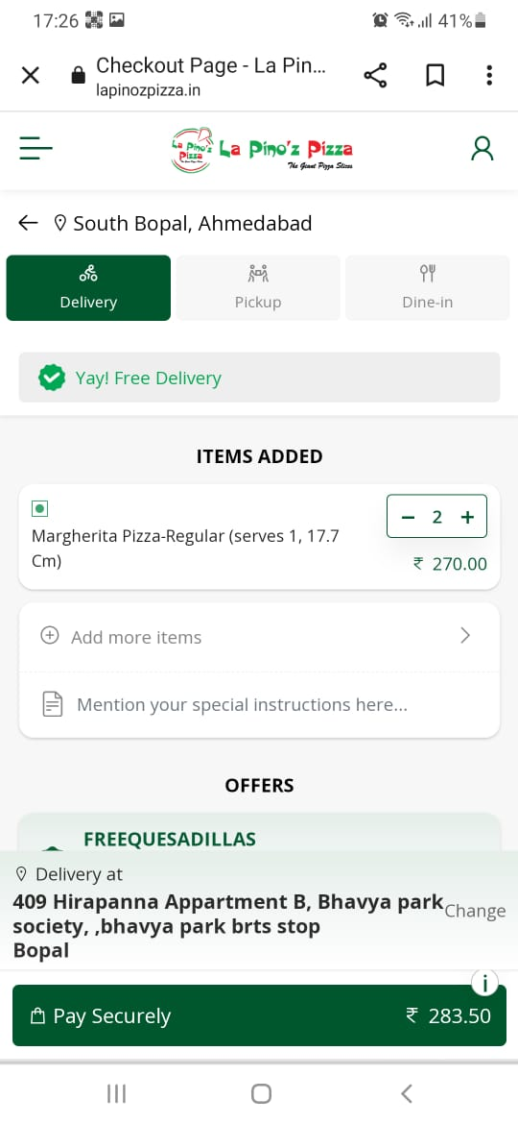

1. Click On “Change” and enter the exact location manually or using automatic Geolocation Click on ‘Select’ for choosing the the address for delivery.



1. Click on “Pay securely”.

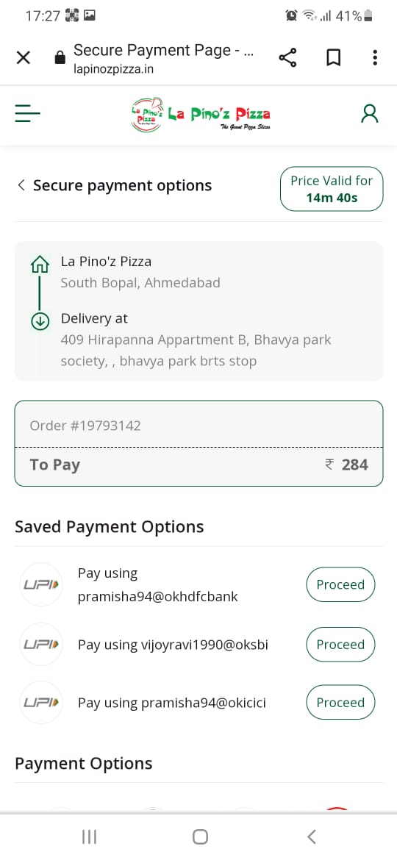

1. Click on ‘Cash’ option in Payment option. But here error message is being displayed saying “Payment By Cash is not available on this order”.

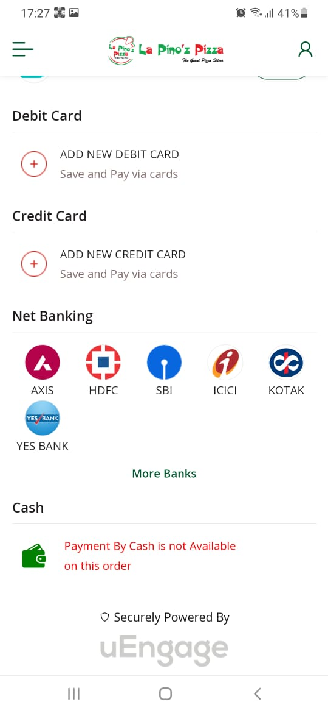

**Issue : Cash on Delivery option is not available for payment option for ordering online via website.**

**Conclusion : Hereby We can conclude that Cash On delivery option is not working for Lapinoz website via Web or Mobile.**